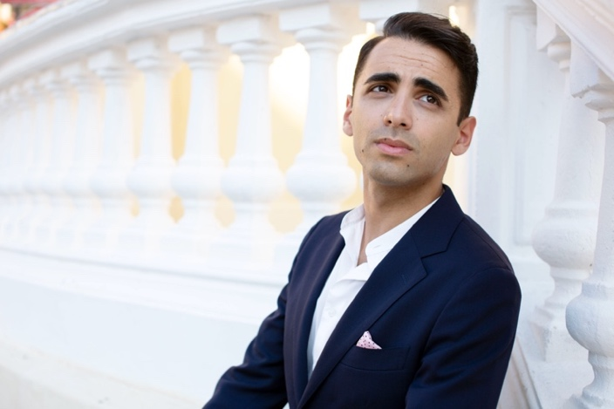
Ferdinando Sulla studied organ and composition at the Conservatory “S. Giacomantonio” in Cosenza and deepens his composition and orchestration studies in Milan with composer Giampaolo Testoni. He graduated with full marks and honors in choral music and choral conducting, at the Conservatory “S. Giacomantonio” in Cosenza and in orchestral conducting at the "Civica Scuola di Musica Claudio Abbado" in Milan. Afterwards he deepens his conducting studies with Gilberto Serembe at the Italian Conducting Academy.

As chorus director he collaborated for important operatic and symphonic productions with Diego Fasolis and Fabio Luisi.

He has also been assistant conductor of Fabio Luisi for several concerts and opera productions.

In the opera's field he has conducted L'italiana in Algeri, Don Pasquale, La Cenerentola, Le donne vendicate, Il barbiere di Siviglia by Paisiello; he debuted at the Rossini Opera Festival conducting the Miserere and the Messa di Milano by Rossini (works of which he edited the critical edition for the Fondazione G. Rossini of Pesaro); then he conducted at the: Festival della Valle d'Itria of Martina Franca; Festival Verdi of Parma; Festival Resurrexit of Siauliai on a special invitation by Lithuanian National Philharmonic Society of Vilnius; Teatro del Maggio Musicale Fiorentino of Florence; Teatro Regio of Parma; Auditorium of Milan; Fondazione Rete Lirica delle Marche; Teatro Rossini of Pesaro; Teatro Verdi of Padua; Teatro della Fortuna of Fano; Teatro dell'Aquila of Fermo; Teatro "Ventidio Basso" of Ascoli Piceno; at the Auditorium Maximum of Cluj.

In the filed of symphonic repertoire he conducted the: Orchestra and Choir of the “Teatro del Maggio Musicale Fiorentino”; “Orchestra Sinfonica G. Verdi” of Milan; “Filarmonica Arturo Toscanini” Orchestra of Parma; “I Filarmonici Friulani” Orchestra; “Filarmonia Veneta” Orchestra; “Filarmonica Gioacchino Rossini” Orchestra; “Orchestra Sinfonica G. Rossini” of Pesaro; “Orchestra di Padova e del Veneto”; Orchestra and Choir of the State Philharmonic “Transilvanjia” of Cluj; “Orchestra I Pomeriggi musicali” of Milan; “Orchestra Magna Græcia”; Klaipeda Chamber Orchestra; “Orchestra I Musici di Parma”; “Roma 3 Orchestra”.

He has conducted the world premiere of works by Giampaolo Testoni and Paolo Furlani.

Graduated with full marks and honors in Musicology at the University of Milan, he has edited the critical edition of the Messa di Milano and the Miserere by Rossini for the "Fondazione G. Rossini" of Pesaro and Casa Editrice Ricordi of Milan; moreover he made the critical edition of Alessandro nell'Indie by Vinci and collaborated with Davide Daolmi to the critical edition of Adelson e Salvini by Bellini and to the critical edition of Petite Messe Solennelle by Rossini.

He was professor at the Accademia del Belcanto "Rodolfo Celletti" in Martina Franca. Currently he teaches at the Civica Scuola di Musica "Claudio Abbado" in Milan and at the "Accademia Teatro alla Scala" in Milan.

In May 2019 he was awarded by Rotary Club as "Young Execelece" for artistic merits.

www.ferdinandosulla.com

