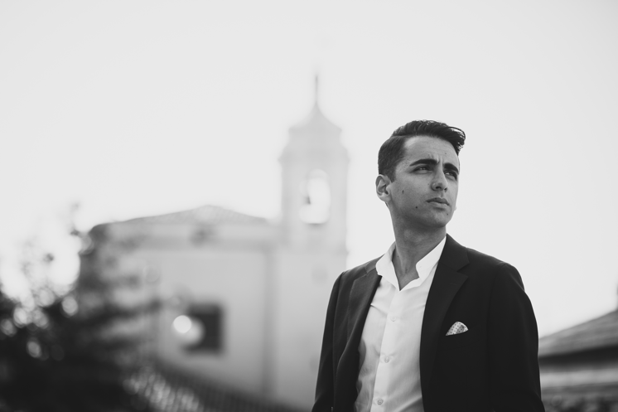
Ferdinando Sulla studied organ and composition at the Conservatory “S. Giacomantonio” in Cosenza and deepens his composition and orchestration studies in Milan with composer Giampaolo Testoni. He graduated with full marks and honors in choral music and choral conducting, at the Conservatory “S. Giacomantonio” in Cosenza and in orchestral conducting at the "Civica Scuola di Musica Claudio Abbado" in Milan. Afterwards he deepens his conducting studies with Gilberto Serembe at the Italian Conducting Academy.
As chorus master he collaborated for important operatic productions with Diego Fasolis and Fabio Luisi, of whom he also has been assistant conductor for several productions.
In the field of opera’s repertoire he has conducted: Don Pasquale by G. Donizetti at the Teatro Regio di Parma (2021) and at the Teatro Verdi di Padova (2021); La Cenerentola by G. Rossini at the OperaEstate Festival (2018); Le donne vendicate by N. Piccinni at the Festival della Valle d’Itria (2017); Barbiere di Siviglia di G. Paisiello at the Teatro Spazio89 di Milano (2017).
He also had his international debut in the symphonic repertoire: at the Rossini Opera Festival in Pesaro (Italy) with critical edition of Miserere and Messa di Milano by G. Rossini, committed to him by Fondazione G. Rossini and Casa Editrice Ricordi; at the XIX Festival Verdi of Parma (2019); at the Teatro del Maggio Musicale Fiorentino (2019); at the Fondazione Orchestra Sinfonica e Coro “G. Verdi” of Milan (2019); at the Festival “Resurrexit” of Siauliai (Lituania) on a special invitation by “Lithuanian National Philharmonic Society” of Vilnius (2018); in the symphonic season of the Filarmonica “Transilvanjia” of Cluj (2017).

In the past concert and operatic seasons he conducted important orchestras and choirs as: Orchestra Filarmonia Veneta (2021), Orchestra “I Filarmonici Friulani” (2021), Filarmonica “Arturo Toscanini” of Parma (2021; 2019), Filarmonica Gioacchino Rossini (2020), Orchestra Sinfonica “G. Verdi” of Milan (2019), choir and orchestra of Teatro del Maggio Musicale Fiorentino (2019), Orchestra di Padova e del Veneto (2018), Orchestra ICO “Magna Græcia” (2018), Klaipeda Chamber Orchestra (2018), choir and orchestra of Filarmonica di Stato “Transilvanjia” of Cluj (2017), Orchestra “I Pomeriggi musicali” of Milan (2016), l’Orchestra “I Musici di Parma” (2012), “Roma 3 Orchestra” (2010).
He conducted world premiere of italian composers as: Giampaolo Testoni (Tre Pezzi Sacri, for female choir and orchestra); Paolo Furlani (Pinocchio in variazioni, for actor and orchestra).

During his professional path he merged historic and research interests to the artistic education. In fact he also obtained the master degree in musicology with full marks and honors in Milan. Consequentially he worked on the critical edition of Alessandro nell'Indie by L.Vinci and collaborated with Davide Daolmi for the critical editions of V. Bellini Adelson e Salvini and G. Rossini Petite Messe Solennelle (orchestral version). In 2020 he set critical edition of Miserere and Messa di Milano by G. Rossini committed by Fondazione G. Rossini with collaboration of Casa Editrice Ricordi.

He was teacher during several masterclasses of vocal interpretation for singers and choral conducting at Accademia del Belcanto “Rodolfo Celletti” - Fondazione Paolo Grassi in Martina Franca, and at “Leonardo Vinci Festival” in Crotone.
He is professor at Civica Scuola di Musica “Claudio Abbado” in Milan, and at Accademia Teatro alla Scala in Milan

In May 2019 he was awarded by Rotary Club as "Young Execelece" for artistic merits.

